1. Earlier, we discussed **Generic Record** but now we will discuss **Specific Record** which is more preferred way to create Avro Object.
2. A screenshot of a computer

   Description automatically generated
3. A screenshot of a computer

   Description automatically generated
4. **Let’s do the Maven Setup = Dependency + Plugin**.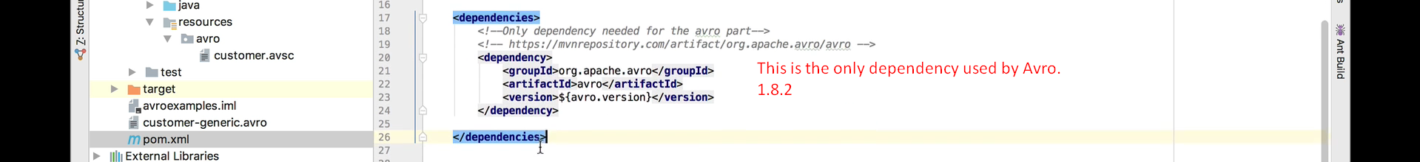
5. 
6. Now we will configure two plugins for a Specific Record.
7. A screenshot of a computer

   Description automatically generated  
     
     
   A computer screen shot of text

   Description automatically generated  
     
   A screenshot of a computer

   Description automatically generated  
     
   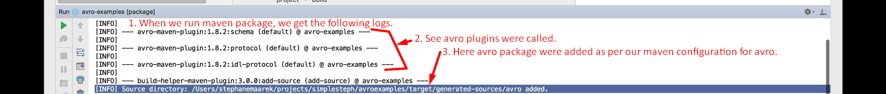  
     
   Let’s see the Code generation output of the maven plugin avro.  
   A screen shot of a computer

   Description automatically generated
8. A screenshot of a computer

   Description automatically generated
9. A screenshot of a computer

   Description automatically generated  
   Uncomment the line#14 from the above code to make code work.
10. Writing Data long with Schema to a file.  
    A screen shot of a computer

    Description automatically generated
11. Reading from avro file.  
    A screen shot of a computer code

    Description automatically generated